**Excel Sales Dashboard – Detailed Project Report**

**1. Introduction**

This project showcases a complete sales analysis process using Microsoft Excel, including professional data cleaning, transformation, and dashboard creation. The objective is to convert raw sales records into insightful and interactive visualizations through pivot tables, charts, slicers, KPIs, and conditional logic.

**2. Objective**

* Clean and prepare sales data for analysis.
* Apply Excel functions to automate categorization and transformation.
* Generate KPIs to summarize performance.
* Design a dashboard for decision-makers to interact with data visually.

**3. Raw Data Overview**

The raw data contained records of following fields:

| **Column Name** | **Description** |
| --- | --- |
| Customer Name | Full name of the customer |
| Product | Item sold (e.g., Shirt, TV) |
| Category | Product type (Clothing, Electronics, Books, Stationery, Home Appliances, Sports etc.) |
| Region | Sales region (East, West, North, South) |
| Quantity | Number of units sold |
| Unit Price | Price per unit |
| Order Date | Date the sale was made |

👉 **Figure 1:** Screenshot of the Raw Sales Data Table (before cleaning)

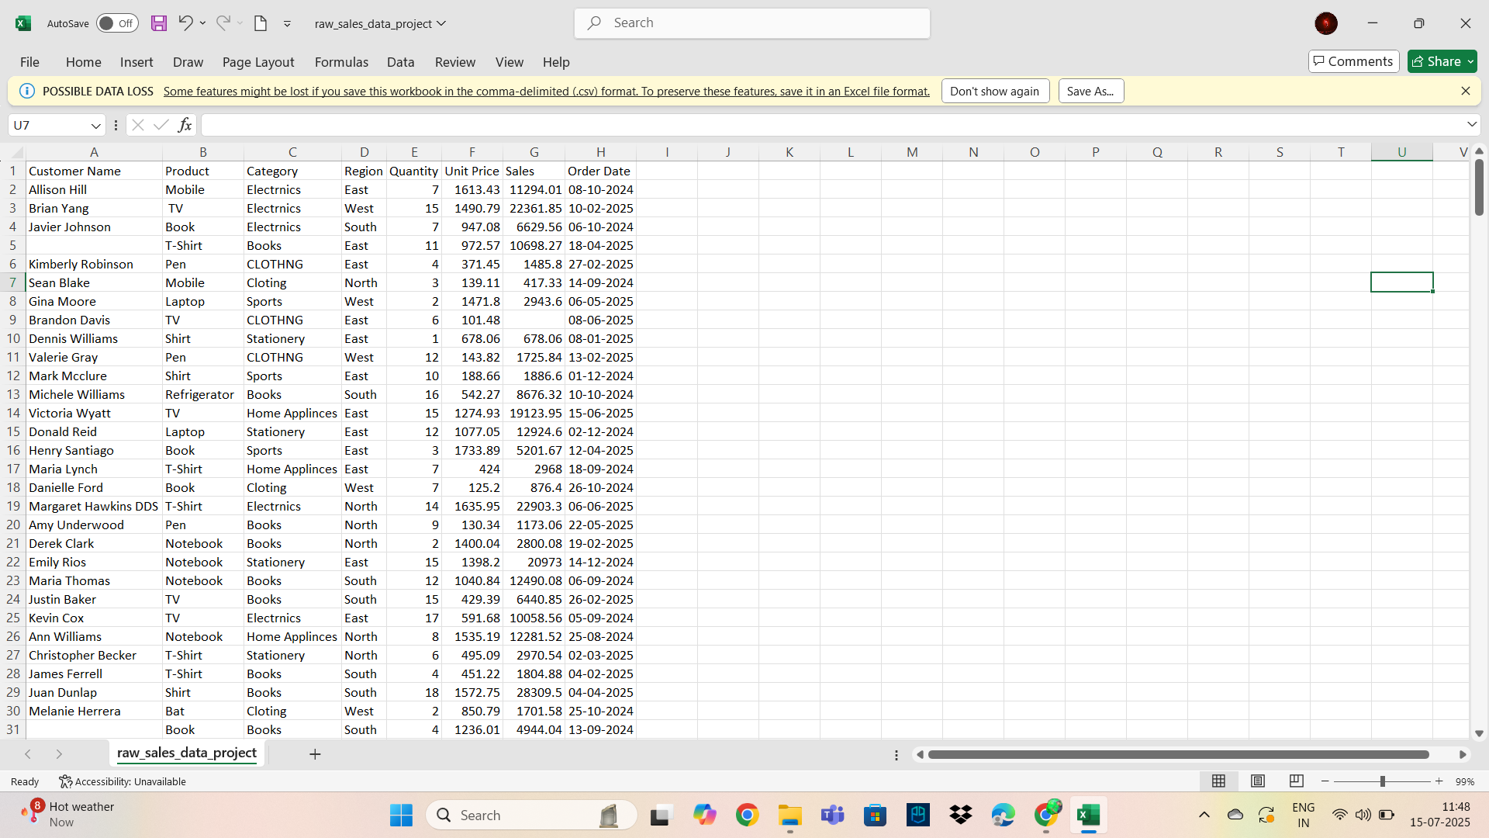

**4. In-Depth Data Cleaning Steps**

Here is the **step-by-step cleaning and transformation process** applied to prepare the data for analysis:

**🔍 4.1 Spell Check**

* Applied **Spelling (F7)** to all text-based columns to ensure consistency in naming (e.g., products, regions, and names)

**🧹 4.2 Removed Empty Rows**

* Used **Filters** on each column.
* Identified and deleted rows where entire records were missing (blank across all or key fields).

**🧾 4.3 Removed Duplicates**

* Used **Remove Duplicates** under the *Data* tab.
* Found and removed **5 exact duplicate records** based on all columns.

**✂️ 4.4 Applied TRIM, CLEAN, and PROPER Functions**

To clean up inconsistencies and formatting in text columns (like customer names and product/category names), used the following formulas:

=PROPER(CLEAN(TRIM(A2)))

* **TRIM ()** removes extra spaces.
* **CLEAN ()** removes non-printable characters.
* **PROPER ()** capitalizes each word appropriately.

**🔄 4.5 Find and Replace**

* Used **Ctrl + H** to correct repeated spelling issues or inconsistent naming (e.g., replacing “T.v” with “Tv”).

**🆔 4.6 Category Correction Using IFS Function**

The **Product** and **Category** columns were mismatched in the raw data. So a new column was created and filled using:

excel

=IFS(

B2="Laptop", "Electronics",

B2="Mobile", "Electronics",

B2="Tv", "Electronics",

B2="Shirt", "Clothing",

B2="T-Shirt", "Clothing",

B2="Pen", "Stationary",

B2="Notebook", "Stationary",

B2="Book", "Books",

B2="Bat", "Sport"

)

✅ This ensured that each product was categorized correctly without relying on incorrect raw mappings.

**🔤 4.7 Converted Column Names to UPPERCASE**

Renamed all column headers to uppercase to maintain uniformity and professionalism.

**👥 4.8 Split Full Names Using Flash Fill**

* Split “Customer Name” into **First Name** and **Last Name** using **Flash Fill** under the *Data* tab.
* Flash Fill smartly detected the pattern when you typed the first names and auto-filled the rest.

**🔃 4.9 Sorted Sales**

* Sorted the data by the **Sales column** (from highest to lowest) to identify top-performing sales first.

**📈 4.10 Sales Performance Classification (IFS Function)**

Instead of using nested IFs, applied **IFS function** to classify sales:

excel

=IFS(

Sales>=30000, "High",

Sales>=20000, "Medium",

Sales<20000, "Low"

)

This categorization was more readable than multiple nested IF()s and improved formula clarity.

**4.11 Calculated column & Formula**

Added the **Revenue** column by using the formula

=QUANTITY * UNIT PRICE

Each row computes the total sale amount per item.

**🎨 4.12 Applied Conditional Formatting**

* Highlighted **Top 10% sales** with yellow colour to instantly identify the best sales.
* Highlighted all **High Performance** sales with a green colour using text rules.

👉 Figure 2: Cleaned Data Table with Formulas and Categorized Columns

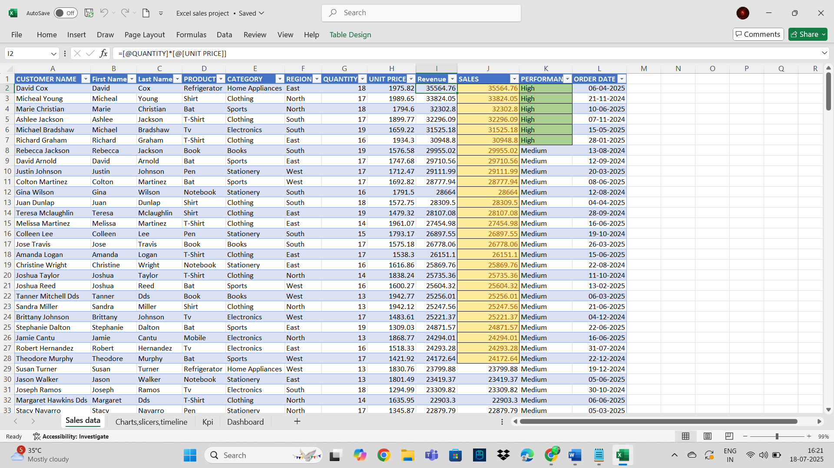

**5. KPI Calculations**

Used the cleaned data to compute:

| **KPI** | **Formula** |
| --- | --- |
| Total Sales | =SUM(Sales) |
| Average Sales | =AVERAGE(Sales) |
| Count of High Sales | =COUNT(Sales) |

👉 **Figure 3:** KPI Summary Table from Excel

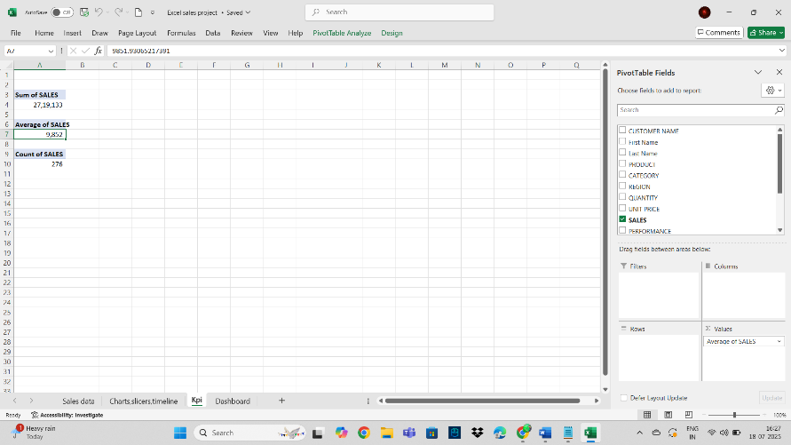

**6. Pivot Table and Charts**

Created Pivot Tables for:

* Sales by **Category**
* Sales by **Region**
* **Monthly** Sales Trend

**Filters/Slicers Added:**

* Category Slicer
* Region Slicer
* Timeline Slicer(Order Date)

Used **slicers** and **timelines** for interactivity and these filter allow dynamic analysis based on the users selection.

**👉 Figure 4:** Pivot Chart and Slicers Layout

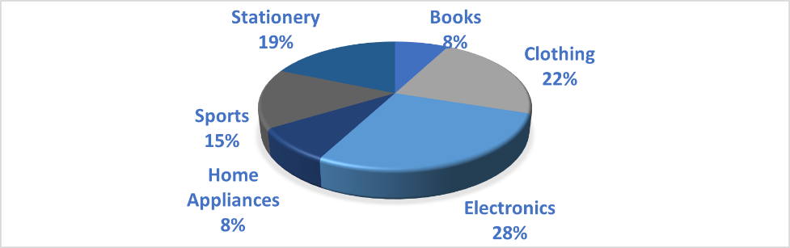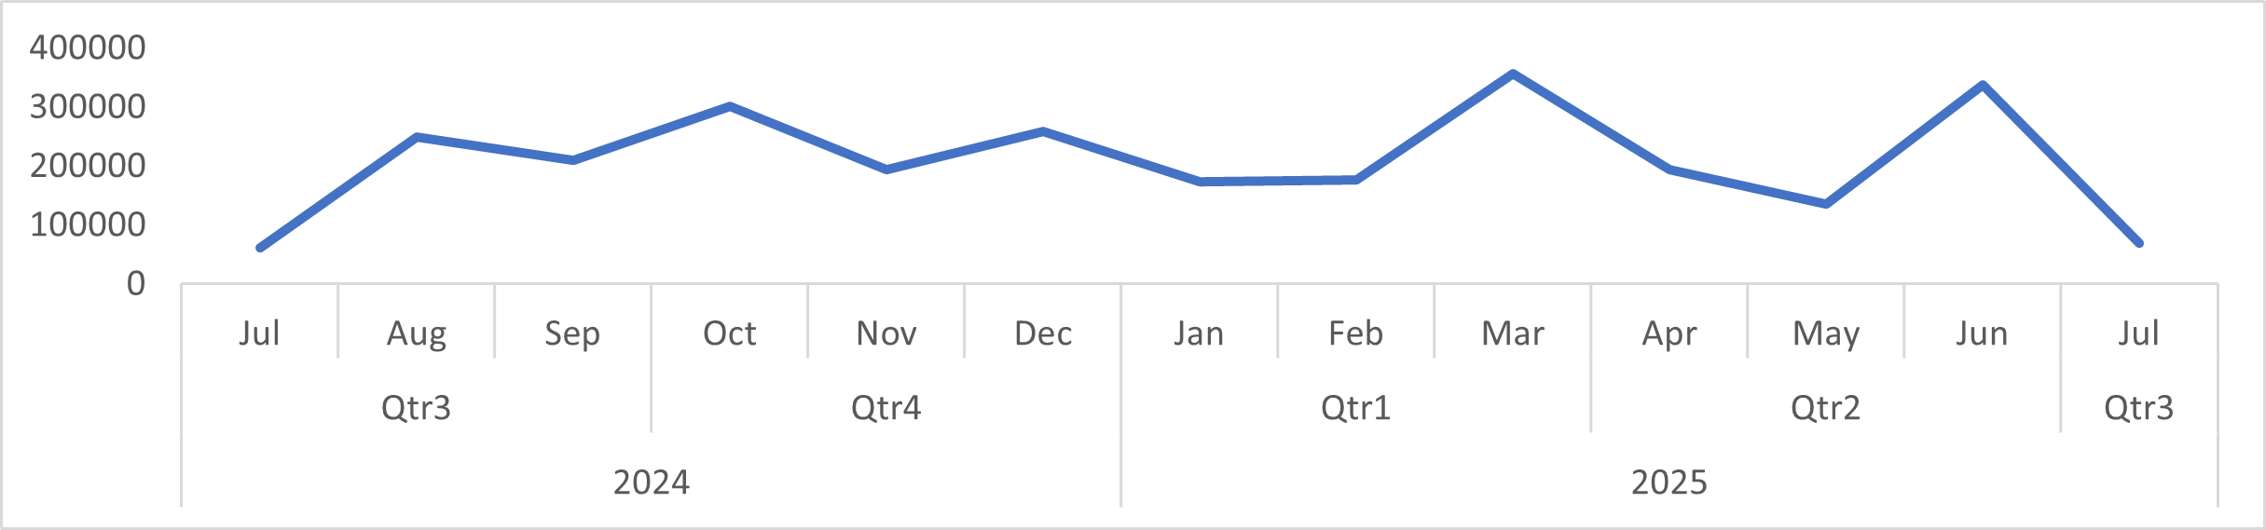

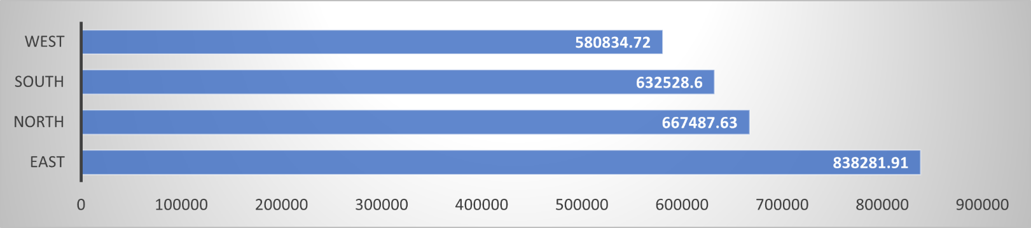

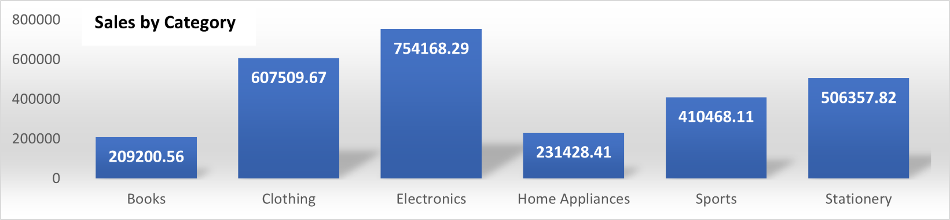

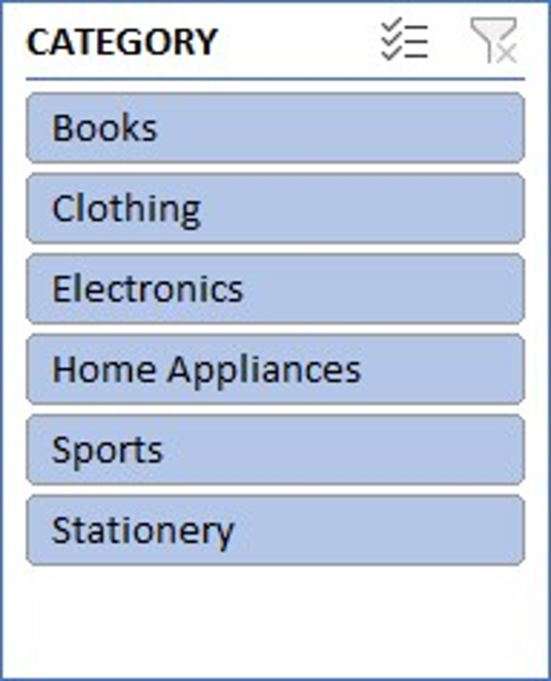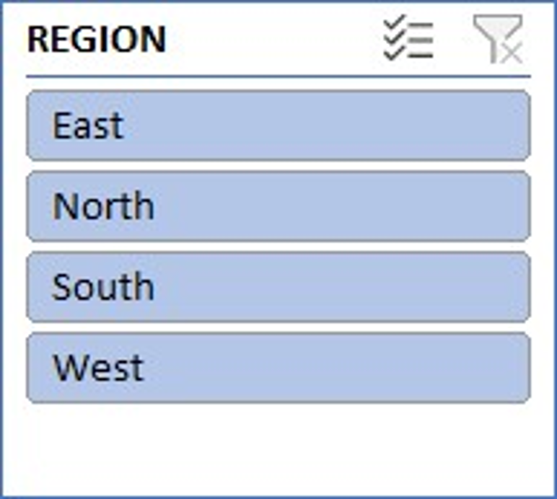

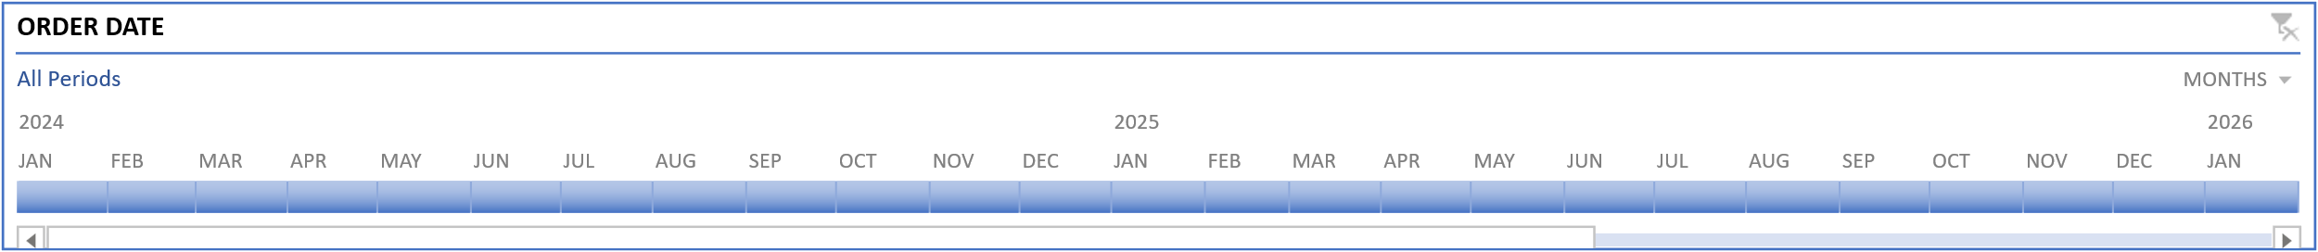

**7. Dashboard Overview**

The dashboard was created on a separate sheet and included:

* Pivot charts (Column, Line, Bar & Pie) to show trends.
* KPI Cards to show Total and Average sales.
* Region and Category slicers for user control.
* Timeline slicer for Order Date to filter daya by months/years/quarters.

Features:

* Clean layout with titles.
* Data connected to original Pivot Tables.
* Real-time updates when filters are applied.

Well-organized layout using Excel’s built-in formatting tools for better visual clarity.

👉 **Figure 5:** Final Sales Dashboard Picture.

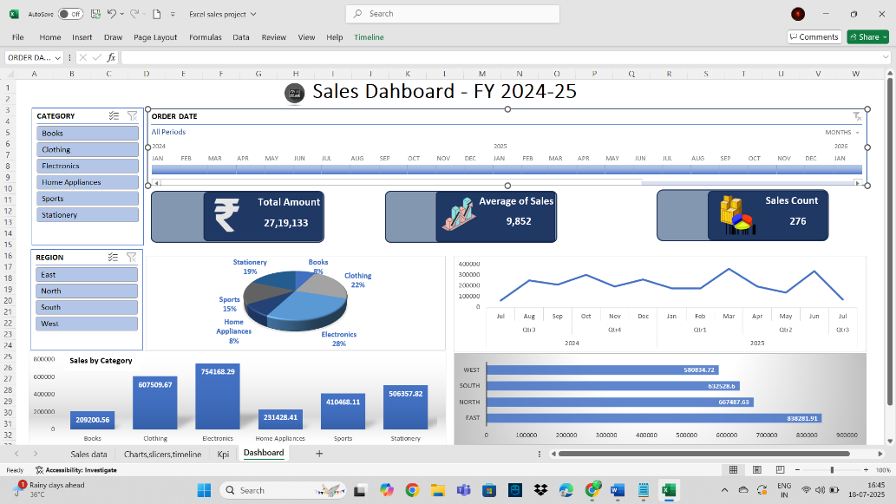

**8. Insights from Data**

* **Top Performing Categories**: Electronics and Clothing generated the most revenue.
* **High Sales Count**: Electronics have high Sales.
* **Time-based Trends**: Seasonal insights visible via timeline filter.
* **Region-wise Performance**: South and North are the top performers.

**9. Tools and Functions Summary**

| **Excel Tool/Function** | **Purpose** |
| --- | --- |
| TRIM, CLEAN, PROPER | Clean and format text |
| IFS | Conditional classification |
| SUM, AVERAGE, COUNT | KPI calculations |
| Flash Fill | Auto-split names |
| Remove Duplicates | Eliminate redundant entries |
| Conditional Formatting | Highlight key insights visually |
| Pivot Tables | Aggregate data |
| Slicers & Timeline | Filter data dynamically |

**10. Conclusion**

The Excel sales project provides a complete view of business performance, from raw data to a clean dashboard. It demonstrates practical Excel skills such as data cleaning, transformation, conditional logic, and dashboarding, making it a strong project for real-world application

**11. Author Information**

**Name:** T Satya Kameswari

**Role:** Excel Data Analyst

**Year:** 2025

**GitHub:**